All nomination forms must be returned to the NAIFA-Indiana office by Nomination’s deadline of June 12, 2025 or postmarked by June 12, 2025 to receive consideration.

Nominations may only be submitted by members of NAIFA-Indiana.

2025

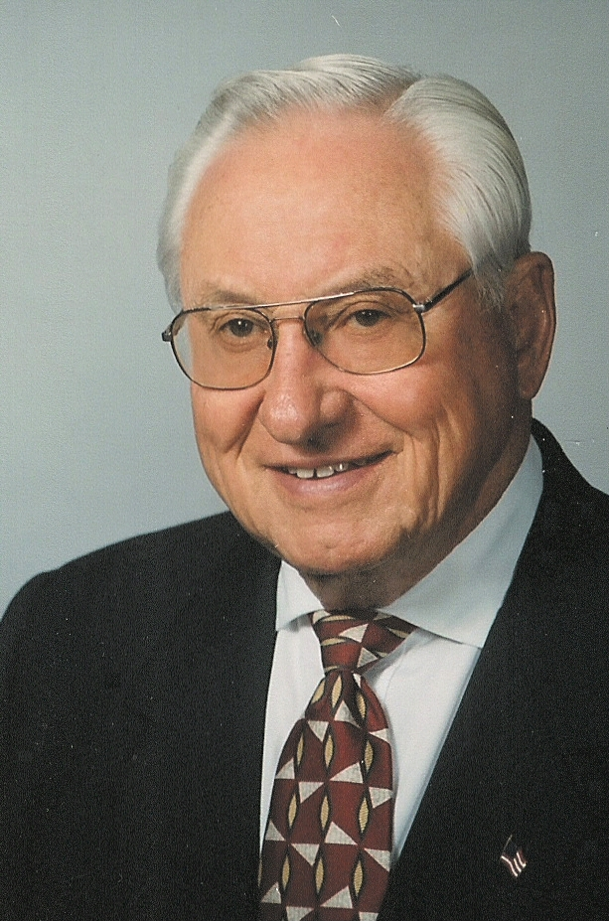

Jack Peckinpaugh
Associate of the Year Award
NOMINATION FORM

for

_________________________________________________________________
(Nominee)

Office Phone # _____________________Office Fax # _______________________

E-Mail Address ______________________________________

_____________________________________________________________________
Office Address City State Zip

NAIFA member making this nomination: ________________________________
(Include a letter stating why you are nominating this individual.)

Date of Nomination ________________________________________

-1-

SEE PAGE 6 OF FORM FOR NOMINATION SUBMISSION INSTRUCTIONS

JACK PECKINPAUGH ASSOCIATE OF THE YEAR AWARD

Selection Criteria & Rules

To give this award the status it merits, the Committee established broad criteria for use in selecting nominees. The nominee should be a living current member of NAIFA-Indiana engaged professionally as follows: agent in personal production, agent in multi-line sales, financial planner, general agent or manager, second line field manager, brokerage director, investments, or a combination of these.

The Nominating Committee established three categories for measurement. Each nominee will be scored on a scale of 1 – 10 in each of these three categories by members of the selection committee. Scores assigned under the NAIFA category will be tripled and scores under INDUSTRY will be doubled.

NAIFA – NAIFA involvement and allied industry organizations.

COMMUNITY – Contributions of involvement and leadership within their communities through organizations, committees, elected offices and religious affiliation.

INDUSTRY – This section involves specific activity within industry.

If your nominee has been nominated before and was not selected, do not hesitate to nominate again. Most recipients are not selected the first year they are nominated. Applications are retained for three years or can be re-submitted with new information.

[Please type or print legibly all information]

What year did the nominee enter the industry? ___________

What year did the nominee join NAIFA? _____________

Has membership in NAIFA been continuous since that date? ___Yes ___No

Business Name: __________________________________________

Companies Represented by Nominee: ______________________________________________

_______________________________________________________________________________

Primary Activities (mark all that apply): _____Agent/Life and Health _____ Agent/Multi-Line

_____ Manager _____ Brokerage Director _____ General Agent

_____ Financial Planner _____Investments _____Other

-2-

NAIFA

A. List positions held in insurance and/or financial planning associations other than NAIFA and the years
held.

______________________________________________________________________________

______________________________________________________________________________

______________________________________________________________________________

B. List all involvement with your company's agent organizations or management organizations
and positions held in these organizations:
______________________________________________________________________________

______________________________________________________________________________

______________________________________________________________________________

C. List all involvement with any former local NAIFA Association (Board and/or Committee positions held): ______________________________________________________________________________

______________________________________________________________________________

______________________________________________________________________________

______________________________________________________________________________

______________________________________________________________________________

D. List all involvement with NAIFA – Indiana (Board, Committee positions held):

______________________________________________________________________________

______________________________________________________________________________

______________________________________________________________________________

______________________________________________________________________________

E. List all involvement with NAIFA at the National level (Committees, Task Force):

______________________________________________________________________________

______________________________________________________________________________

______________________________________________________________________________

______________________________________________________________________________

-3-

F. Has the nominee attended NAIFA national conferences, Congressional Congress or APEX
meetings in the past? YES____ NO____

If yes, please provide details:

_____________________________________________________________________________

_____________________________________________________________________________

_____________________________________________________________________________

G. Is the nominee a current contributor to the Insurance and Financial Advisors Political Action Committee (IFAPAC)? YES____ NO____
What is the current annual contribution?
Bronze ($300 to $599 per year) ____________
Silver ($600 to $999 per year) ____________
Gold ($1000 to $2499 per year) ____________
Platinum ($2500 to $4999 per year) ____________
Capitol ($5,000 or more per year) ____________

How many years has the nominee been a contributor to IFAPAC? ____

What is your lifetime contribution to IFAPAC? _____________
(NAIFA Indiana can provide all of this information to you.)

H. Is the nominee a Leadership in Life (LILI) Graduate? YES_____ NO_____

If yes, are you a former or current LILI Moderator? YES_____ NO_____

I. Has the nominee developed CE courses for NAIFA-IN? YES____ NO_____

J. Has the nominee been a CE presenter for NAIFA-IN? YES____ NO_____

K. What industry related designations does the nominee have?

_____________________________________________________________________________

L. Describe any other industry involvement and awards that should be brought to the
attention of the Selection Committee.

______________________________________________________________________________

______________________________________________________________________________

______________________________________________________________________________

-4-

COMMUNITY

A. List the civic organizations the nominee has belonged to and the leadership positions held in these
organizations: ____________________________________________________________________________________

____________________________________________________________________________________

____________________________________________________________________________________

____________________________________________________________________________________

B. List the various community activities the nominee has been involved with and the leadership positions
held in these organizations:
____________________________________________________________________________________

____________________________________________________________________________________

____________________________________________________________________________________

____________________________________________________________________________________

C. List the various charitable organizations the nominee has been involved with and the leadership positions
held in these organizations:
___________________________________________________________________________________

___________________________________________________________________________________

___________________________________________________________________________________

D. List the various religious organizations that the nominee has been involved with and the leadership positions held in these organizations: ____________________________________________________________________________________

____________________________________________________________________________________

____________________________________________________________________________________

____________________________________________________________________________________

E. List any community/civic/charitable/or religious awards or special recognition the nominee
has received and the dates received:
____________________________________________________________________________________

____________________________________________________________________________________

____________________________________________________________________________________

____________________________________________________________________________________

-5-

INDUSTRY

I.** If the nominee is in personal production, please complete this section. Otherwise, please proceed
to Section II.

A. Nominee produces in the following areas:

__ Life Insurance and Annuities sales

__ Multi-line sales

__ Health Insurance sales

__ Group sales

__ Investments

B. What production clubs and/or honors has nominee qualified for or received from companies?
Please list the club levels or describe the honor(s) and the number of years qualified for these
clubs or honors.
_________________________________ _________________________________
_________________________________ _________________________________
_________________________________ _________________________________

C. Is the nominee a member of the Million Dollar Round Table? ________________
If so, list current MDRT Status:
Life Member ______________
Qualifying Member ______________
Qualifying and Life ______________
Years qualified for MDRT ____________

D. How many times has the nominee received the NAIFA Quality Award (NQA)? _________

How many times has the nominee received the National Sales Achievement Award (NSAA)? _________

E. Number of individual client lives currently insured by the nominee: _____

Number of groups currently insured by the nominee: _____-

F. If nominee is involved in investments, please answer the following:

The number of clients the nominee has: ______

The total amount of assets under management: _________

G. If nominee is a multi-line agent, please indicate:
1. Number of lives insured/served for life, health, annuities and investments? ______

2. What percent of property-casualty business has been multi-lined with life insurance? ________%

-6-

II.** If the nominee is a Manager, General Agent or Brokerage Director, please complete this section.

A. How long has the nominee been in a management or brokerage position? _____________

How many agents/brokers are in the agency or unit currently? _________
What is the agency's or unit's total first year commissions for the previous year? ___________
How does agency or unit rank nationally, compared to other agencies or units in nominee’s
primary company? (If applicable) ____________
How many agents were in the agency or unit? 3 yrs. ago ____ 5 yrs. ago ____
What was the agency or unit's first year commissions total? 3 yrs. ago _______
5 yrs. ago _______

B. Did you ever work in personal production previously? YES ___ NO ___

If yes, for how many years? ____

C. What management awards or recognitions has nominee received from: (List the years received)
The home office?
________________________________________________________________

________________________________________________________________

________________________________________________________________

The insurance industry?
________________________________________________________________

________________________________________________________________

________________________________________________________________

**IMPORTANT, PLEASE READ BEFORE SUBMISSION: IF THE NOMINEE HAS MADE A SIGNIFICANT CAREER CHANGE WITHIN THE PAST 5 YEARS BETWEEN SECTIONS I AND II OF THE INDUSTRY CATEGORIES, PLEASE ANSWER ALL OF THE QUESTIONS IN BOTH SECTIONS I AND II UNDER THE INDUSTRY CATEGORY.

Nomination Application Submission Instructions
Nomination forms should be sent to:

NAIFA-IN Peckinpaugh Award Selection Committee
PO Box 459, Fishers, IN 46038

They should include supplemental letters of recommendation, if possible.
If you have any questions, please contact the NAIFA-IN office at (317) 844-6268.

-7-

